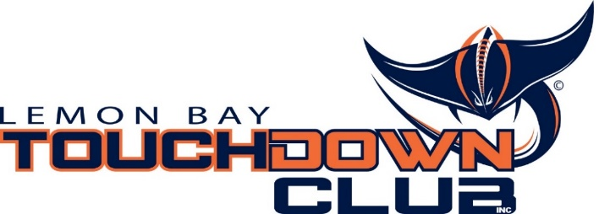

LBHS Touchdown Club
Business and Personal Football Program Ad

Please consider advertising your business or giving a “Shout Out” to your favorite football player, cheerleader, or band member in the 2018 Manta Football Program. Advertisers will be announced at each of our home games in recognition of your support. Limited Ad Space available, do not delay.

The pries below are for black & white ads ONLY. No color is available.

Full Page $150

Half Page $75

Quarter Page $40

Business Card $28

Ads and payments must be received by August 24th

*** Send Ads by e-mail to carlabounds4@gmail.com ***

For any questions contact: Carla Bounds (941) 539-3700

Please make checks payable to: Lemon Bay Touchdown Club
PO Box 38
Englewood, FL 34295

Name: ____________________________________________

Phone: _________________________ Email: ______________________________

Ad Size: ______________ Amount Paid: _______________________

